SRM Institute of Science and Technology College of Engineering and Technology

**DEPARTMENT OF ECE**

SRM Nagar, Kattankulathur – 603203, Chengalpattu District, Tamilnadu

Academic Year: 2023-24 (Odd)

Question Bank : Unit 1 Date: 17/07/2023

Course Code & Title: 18ECC301T - Wireless Communications Year & Sem: VII

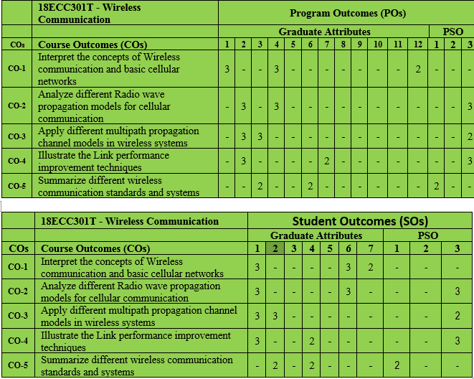

**PART -B**

|  |  |  |  |  |
| --- | --- | --- | --- | --- |
| **S No** | **Answer All Questions** | **CO** | **BL** | **PO** |
| 1 | What are the classifications of mobile radio transmission systems? (hint – Simplex, half duplex, full duplex) | 1 | 2 | 12 |
| 2 | “Paging systems are an example of simplex communications”. Justify the aforementioned statement with the help of a block diagram. | 1 | 2 | 12 |
| 3 | With the help of a block diagram elaborate on cordless telephone systems. | 1 | 2 | 12 |
| 4 | With the aid of a block diagram brief about cellular telephone systems | 1 | 2 | 12 |
| 5 | What do you mean by forward and reverse channel with respect to cellular communications? | 1 | 2 | 12 |

|  |  |  |  |  |
| --- | --- | --- | --- | --- |
| 6 | What do you mean by Frequency reuse? | 1 | 2 | 12 |
| 7 | “Hexagonal shapes are chosen as the optimum cell geometry”. Ornate the importance of the aforementioned statement. | 1 | 2 | 12 |
| 8 | Define Frequency reuse distance. | 1 | 2 | 12 |
| 9 | What is a cell and a cluster? | 1 | 2 | 12 |
| 10 | For a cluster size of 7, if there are 490 channels used for the entire cluster. Calculate how many frequency bands can be handled by a cell. Also calculate the frequency reuse distance for a cell radius of 780 metres. | 1 | 3 | 12 |
| 11 | What a mobile engineer should do to find the nearest co-channel neighbors of a particular cell? | 1 | 2 | 12 |
| 12 | What are the channel assignment strategies? | 1 | 2 | 12 |
| 13 | Define handoff and dwell time. | 1 | 2 | 12 |
| 14 | Elaborate on the classification of Handoff. | 1 | 2 | 12 |
| 15 | Mention the types of handoff based on the cell, BSC and MSC switching. | 1 | 2 | 12 |
| 16 | “I use *different antenna heights* and *Tx power levels* to provide large and small cell coverage”. Identify me and elaborate on the significance of my existence. | 1 | 3 | 1 |
| 17 | Define co channel reuse ratio and What is the co-channel reuse ratio for a cluster size 7. | 1 | 3 | 1 |
| 18 | What is co channel interference? | 1 | 2 | 12 |
| 19 | Define adjacent channel interference | 1 | 2 | 12 |
| 20 | Define Grade of service and traffic intensity. | 1 | 2 | 12 |
| 21 | Briefly elaborate on blocked call clear systems and write the expression for the same. | 1 | 3 | 1 |
| 22 | What is blocked call delay system? Write the expression for the same. | 1 | 2 | 12 |

|  |  |  |  |  |
| --- | --- | --- | --- | --- |
| 23 | If a group of 100 users made 30 calls in one hour, and each call had an average call duration (holding time) of 5 minutes, then what is the traffic intensity (in erlangs)? | 1 | 4 | 4 |
| 24 | What is cell sectoring? | 1 | 2 | 12 |
| 25 | Enumerate the importance of microcell zone concept? | 1 | 2 | 12 |
| 26 | “As New Area is ¼ of the older area (now one bigger cell include approximately 4 smaller cell), therefore the capacity of system is increased by 4 times”. Justify the aforementioned statement if the Total BW available is 25MHz and each user Requires 25kHz. | 1 | 4 | 4 |
| 27 | What are the techniques used to expand the capacity of cellular system? | 1 | 2 | 12 |
| 28 | If a transmitter produces 50 watts of power, express the transmit power in units of (a) dBm, and (b) dBW and find the far field distance for an antenna with maximum dimension of 2 m and operating frequency of 1 GHz. | 1 | 4 | 1 |

**PART -C**

|  |  |  |  |  |
| --- | --- | --- | --- | --- |
| **S No** | **Answer All Questions** | **CO** | **BL** | **PO** |
| 1 | With the help of a timing diagram explain how a call to a mobile user initiated by a landline subscriber is established. | 1 | 3 | 1 |
| 2 | With the aid of a timing diagram explain how a call initiated by a mobile is established. | 1 | 2 | 12 |
| 3 | Define Handoff and what are the different types of handoff? Explain each with the help of a neat diagram. | 1 | 2 | 12 |
| 4 | 1. Describe the Channel assignment strategies. 2. Brief about guard channel concept. | 1 | 3 | 1 |
| 5 | Explain in detail the strategies of Handoff. | 1 | 3 | 1 |
| 6 | With the help of a diagram and equation describe Co-Channel Interference  & System Capacity. | 1 | 3 | 1 |
| 7 | How many users can be supported for 0.5% blocking probability for  the following number of trunked channels in a BCC system? (a) 5, (b) 10, (c)=20. Assumed that each user generates 0.1 Erlangs of traffic. (The graph below can be used) | 1 | 4 | 4 |

|  |  |  |  |  |
| --- | --- | --- | --- | --- |
|  |  |  |  |  |
| 8 | Discuss the techniques involved in improving Coverage & Capacity in Cellular system. | 1 | 2 | 12 |
| 9 | 1. “As New Area is 1/N of the older area (now one bigger cell include approximately 4 smaller cell), therefore the capacity of system is increased by N times”. Justify the aforementioned statement if the Total BW available is 25MHz and each user requires 25kHz. 2. For the path loss exponent of 4 and cell splitting of 0.5, calculate the ratio of Pt1 Transmit Power at old cell boundaries) to Pt2 (Transmit Power at new cell boundaries). | 1 | 4 | 4 |
| 10 | Explain in detail 60 degrees and 120 degrees sectoring. | 1 | 2 | 12 |
| 11 | An urban area has a population of 2 million residents. Three competing trunked mobile networks (systems A, B, and C) provide cellular service in this area. System A has 394 cells with 19 channels each, system B has 98 cells with 57 channels each, and system C has 49 cells, each with 100 channels. Find the number of users that can be supported at 2% blocking if each user averages 2 calls per hour at an average call duration of 3 minutes. Assuming that all three trunked systems are operated at maximum capacity, compute the percentage market penetration of each cellular provider. (The graph below can be used) | 1 | 4 | 4 |

|  |  |  |  |  |
| --- | --- | --- | --- | --- |
|  |  |  |  |  |
| 12 | If a total of 33 MHz of bandwidth is allocated to a particular FDD cellular telephone system which uses two 25 kHz simplex channels to provide full duplex voice and control channels, compute the number of channels available per cell if a system uses (a) 4-cell reuse, (b) 7-cell reuse (c) 12-cell reuse. If 1 MHz of the allocated spectrum is dedicated to control channels, determine an equitable distribution of control channels and voice channels in each cell for each of the three systems. | 1 | 4 | 4 |
| 13 | If a signal to interference ratio of 15 dB is required for satisfactory forward channel performance of a cellular system, what is the frequency reuse factor and cluster size that should be used for maximum capacity if the path loss exponent is (a) n = 4 , (b) n = 3? Assume that there are 6 co-channels cells in the first tier, and all of them are at the same distance from the mobile. Use suitable approximations. | 1 | 4 | 4 |
| 14 | A certain city has an area of 1,300 square miles and is covered by a cellular system using a 7-cell reuse pattern. Each cell has a radius of 4 miles and the city is allocated 40 MHz of spectrum with a full duplex channel bandwidth of 60 kHz. Assume a GOS of 2% for an Erlang B system is specified. If the offered traffic per user is 0.03 Erlangs, compute (a) the number of cells in the service area, (b) the number of channels per cell, (c) traffic intensity of each cell, (d) the maximum carried traffic; (e) the total number of users that can be served for 2% GOS, (f') the number of mobiles per channel, and (g) the theoretical maximum number of users that could be served at one time by the system. (The graph below can be used) | 1 | 4 | 4 |